**Transformation Description**

We will use multistage data transformation because this method allows to easily controlling the process of data loading.

Transformation flow

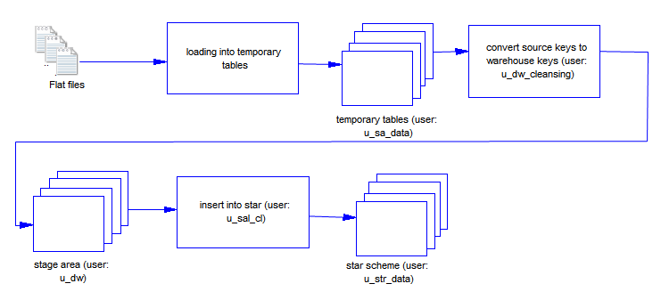

To transforming data we will use PL/SQL because it's the most flexible and powerful mechanism data processing.

**Loading to SAL Layer Data**

Table DIM_CUSTOMERS

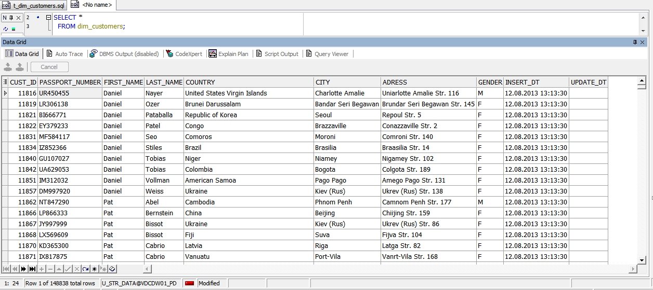

Table DIM_CARS

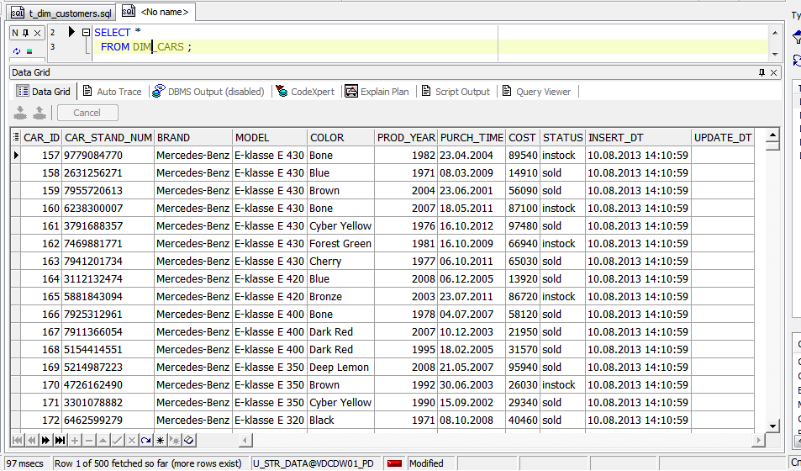

Table DIM_EMPLOYEES_SCD

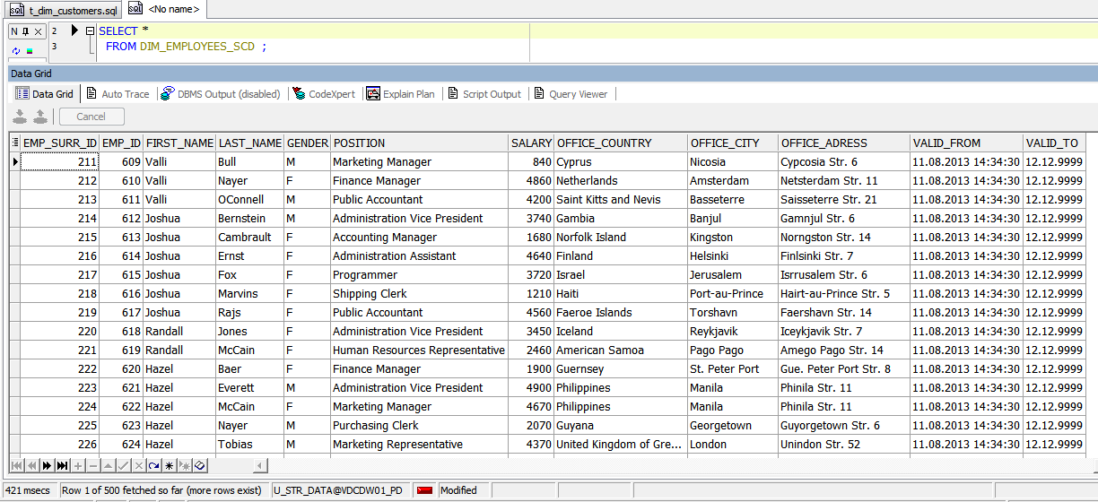

Table DIM_GEO_LOCATIONS_SCD

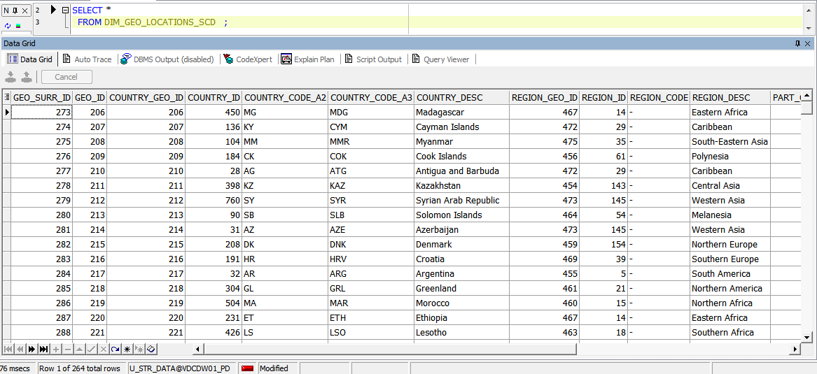

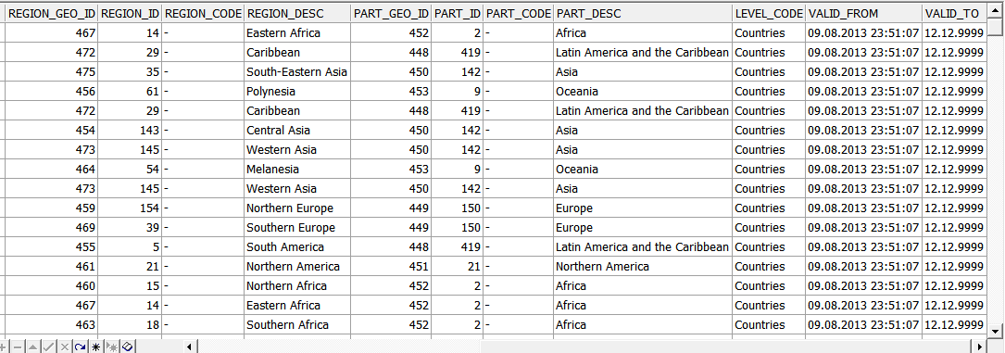

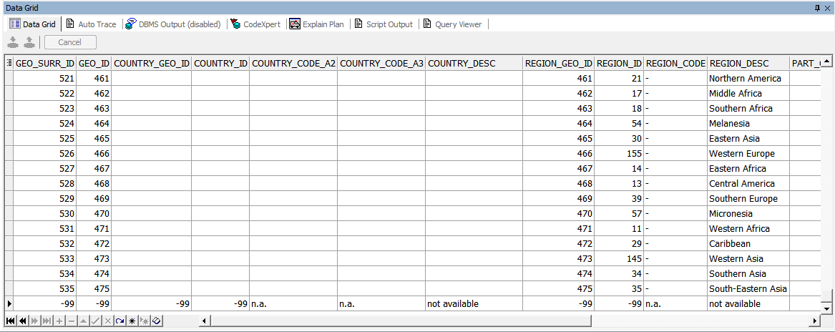

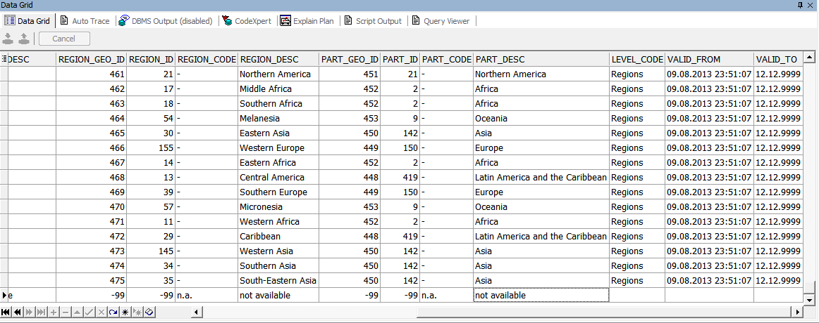

Table DIM_TIMES

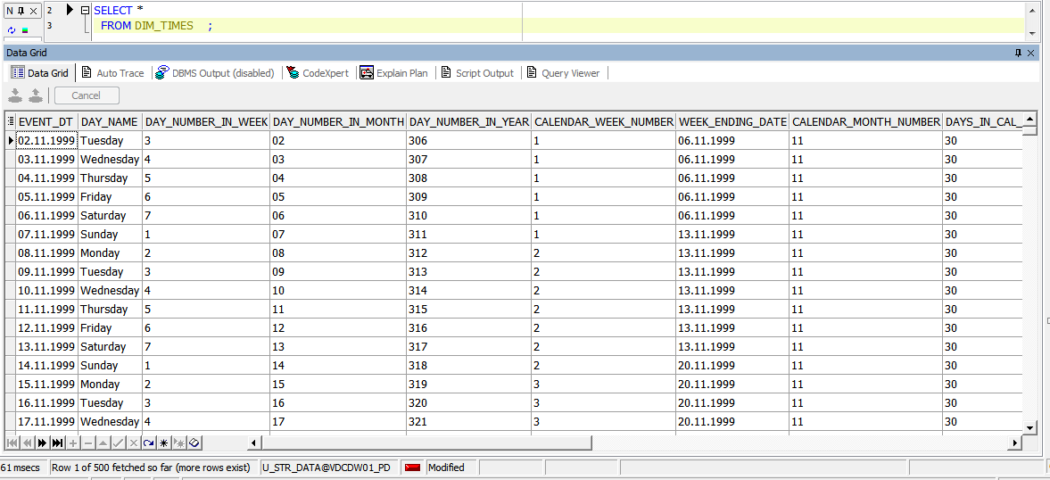

Table FCT_SALES_DD

